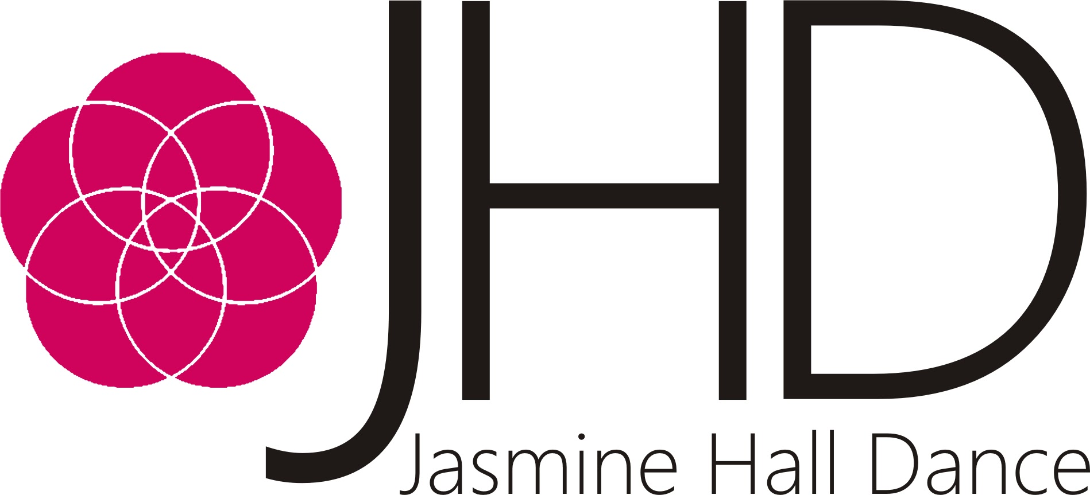

JHD @ Home Booking Form

How many exercises would you like to purchase?
1 Exercise - £5 (this is the price per video)

5 Exercises - £22.50 (discount included)

10 Exercises - £45 (discount included)

Other - State the number of videos you would like: _____________________
(There will be no discount included on bespoke number orders)

Which exercises would you like to purchase?
01. The Dance Creator 06. Parachute Time

02. Under The Sea 07. The Scrunchie Dance

03. The Handshake Challenge 08. Mirroring

04. How to Bake a Cake 09. Let’s Make a Dance Film

05. Our Secret Garden 10. My Home

Details Required:

Name: _______________________________________________________________________________

Address: ____________________________________________________________________________
____________________________________________________________________________

Email Address: _____________________________________________________________________

Phone Number: ____________________________________________________________________

Once you have returned your booking form, an invoice will be sent to your email address and your purchase will be sent to you upon payment.

Please make your purchase to the following account:

Bank Account: Jasmine Hall Dance
Account Number: 62219209
Sort Code: 60-83-71
Reference: HOME_YOUR SURNAME

Thank you for your custom and we hope you enjoy taking part in JHD @ Home!

